PicoSatellite - Power Subsystem Interface Control Document

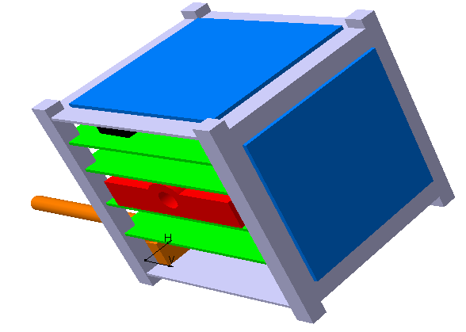

Ryerson University
Space Systems and Dynamics and Controls Group

Table of Revisions
Prepared by | Date | Version | Reason for revision
Mike Alger | April 26th 2007 | 1.0 | Initial Draft/ organization
Mike Alger | May 20th | 2.0 | Major Additions
Mike Alger | June 4 | 2.1 | Additions
Mike Alger | July 21 2007 | 2.3 | Additions and corrections to schematics

Contents
Table of Revisions i
Contents ii
List of Figures iv
List of Tables iv
Acronyms iv
1 Introduction 6
1.1 Requirements 6
2 Interface 6
3 Analysis 7
4 Design 7
4.1 Uninterruptible feed lines 7
4.1.1 3.3V line 7
4.1.2 5 volt line 10
4.2 Controllable Feed lines 10
4.2.1 3.3V 250 mA lines 11
4.2.2 3.3V 850 mA lines 12
4.3 Feed line control mechanism 13
4.3.1 Minimum voltage detection 13
4.3.2 OCTAL BUFFER 15
4.4 Solar cell measurement and power transfer bus 15
4.4.1 Standard double cell case 15
4.4.2 One cell case 17
4.5 Battery charger 18
4.5.1 BQ24002 monolithic charger IC 18
4.5.2 Max 1760 voltage boosting circuit 19
4.5.3 Solar cell output 20
4.6 Battery monitor 20
4.7 System wide interface 21
4.8 Microcontroller 22
4.9 Overall schematic design 22
5 Physical implantation 25
5.1 PCB Design 25
5.2 Hand Assembly instructions 25
5.2.1 Battery terminal connection 25
5.2.2 Uninterruptible 3V 26
5.2.3 Uninterruptible 5V 27
5.2.4 Controllable supply 1 (PS1) 27
5.2.5 Controllable supply 2 (PS2) 28
5.2.6 Controllable supply 3 (PS3) 28
5.2.7 Controllable supply 4 (PS3) 29
5.2.8 Jumpers 30
5.2.9 Single solar cell 30
5.2.10 Battery charger 31
5.2.11 Battery level check and main microcontroller 31
5.2.12 Remaining solar cells 32
6 Modifications/Recommendations/Errors Ver2.1 33
7 Failure modes 34
8 Software design 34
8.1 Pseudo code design 34
8.2 C Code 34
8.3 Testing instructions 34
Appendix: A Bill of materials 35
A.1 Final satellite 38
A.1.1 Components 38

List of Figures
Figure 1: 3.3V uninterruptible supply circuit 9
Figure 2: 5 volt step up and supply circuit 10
Figure 3: 3.3V 250 mA power supply lines (PS 1&3) 11
Figure 4: 3.3V 800 mA power supply line (PS 2 & 4) 13
Figure 5: feed line control mechanism 15
Figure 6: two solar cell circuit 17
Figure 7: single solar cell circuit 18
Figure 8: Battery charger circuit 20
Figure 9: battery monitor circuit 21
Figure 10: interface to the rest of the satellite 21
Figure 11: microcontroller pin-out 22
Figure 12: 23
Figure 13: 24
Figure 14: PCB layout 25

List of Tables
Table 1: Interface matrix 6
Table 2: Verification tool (embedded spreadsheet if file in .doc format) 14
Table 3: Key Diode Characteristics 16

Acronyms
Abbreviation | Full form
AOCS | Attitude and Orbit Control System
AODS | Attitude and Orbit Determination System
ACS | Attitude Control System
C&DH | Command and Data Handling
COMM | Communications
CONOPS | Concept of Operations
COTS | Commercial Off the Shelf
COCOM | Coordinating Committee on Multilateral Export Controls
DTMF | Dual Tone Multi Frequency
FFBD | Functional Flow Block Diagram
GPS | Global positioning system
I2C | Inter-integrated-circuit bus
IMU | Inertial Measurement Unit
JPEG | Joint Photographic Experts Group
MEMS | Micro Electro-Mechanical systems
OBC | Onboard Computer
PCB | Printed circuit board
PCI | Peripheral Communications Interconnect
POST | Power on Self Test
TTL | Transistor to Transistor Logic
UART | Universal Asynchronous Receiver Transmitter
WBS | Work Break down schedule

Introduction
The power subsystem on the Pico satellite will act as a switch able distribution subsystem and will take advantage of the system wide bus to receive commands and send responses. The power subsystem is also responsible for charging the satellites lithium ion battery and monitoring the satellites solar cell outputs throughout the spacecrafts life.

Requirements
Overall
- Must supply power to other spacecraft systems
- Must have controllable lines for non essential systems
- Must charge the battery safely and reliably
- Must monitor output of solar cells (aiding attitude determination subsystem)
- System must supply a 3.3V uninterruptible line for the C&DH module
- System must supply a 6- 5 V uninterruptible line for the radio
- System must supply a switchable 3.3V 250mA line for the ADS
- System must supply a switchable 3.3V 750mA line for the ACS
- System must supply a switchable 3.3V 250mA line for the payload
- System must supply a switchable 3.3V 800mA line for the thermal management system
- System should utilize only the top surface of the board (heater and its control circuit will be placed on the bottom
- System must perform a check before enabling itself on the system bus
Derived from battery choice
- Solar cells must deliver > 3.6 V to allow a charge of the cells
- Protection circuit must exist to prevent over discharge of the cells

Interface
Table 1: Interface matrix
Type | Input | Output
Power | 11 Raw Solar cells  Battery | 3.3 uninterrupted  5V uninterrupted  Battery  Feed line 1 (3.3V 200 mA)  Feed line 2 (3.3V 800 mA)  Feed line 3 (3.3V 200 mA)  Feed line 4 (3.3V 800 mA)
Data | Programming interface (PGC PGD)  System wide reset (activates when brought low)  Commands to turn on supply lines  Commands to turn off supply lines  Commands requesting Battery Voltage  Commands Requesting battery current  Commands requesting remaining battery life | Battery voltage  Battery current draw  Estimated Battery life in mAhrs
Structure | 1 Standard PCB card (see structure document for details) | Connection to structure in corners
Thermal | 1 micro heater | 4 thermal pads in corner
Electrical noise |  | Possible 1 MHz from DC-DC converters

Analysis
Table 2
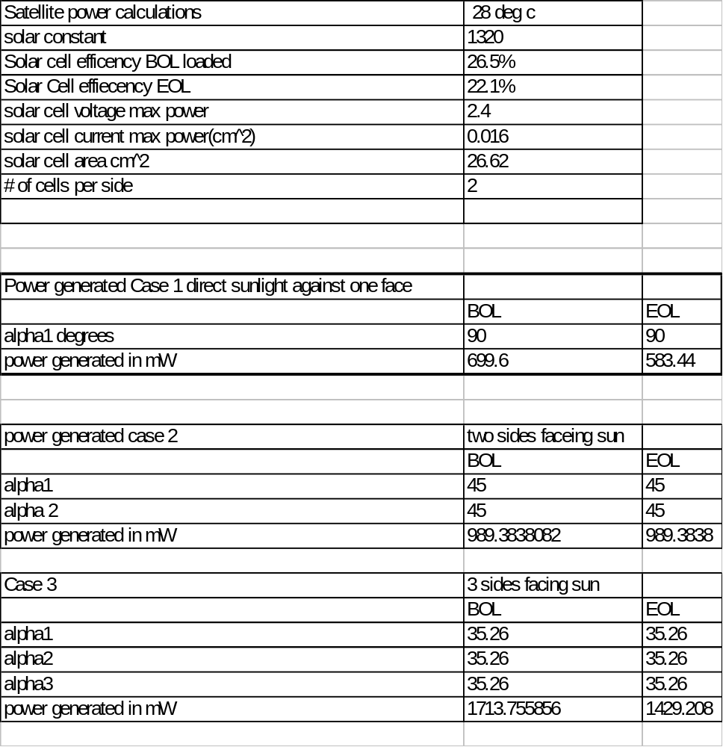

Table 3: Power consumpstion (without heaters on)
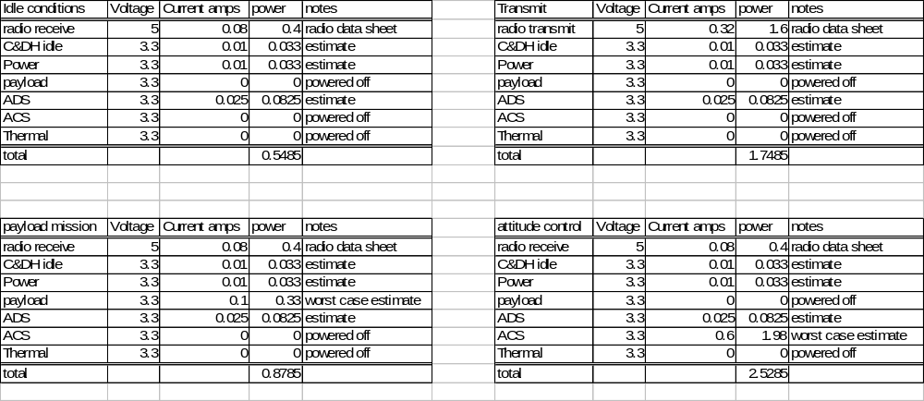
Table 4: Power consumption (with heaters on)
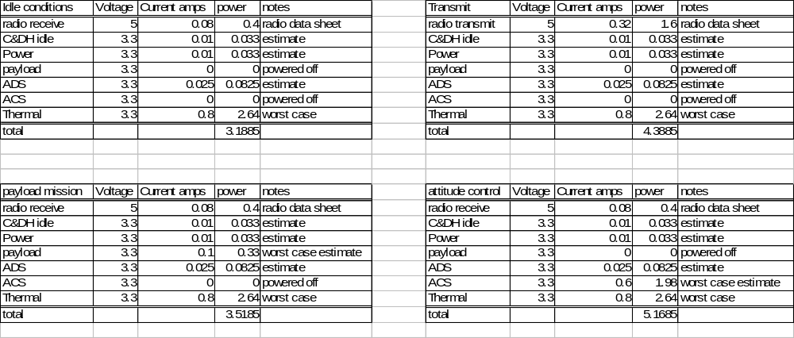

Design

Uninterruptible feed lines
This satellite has two uninterruptible power supply lines one is for the main C&DH board which runs at 3.3 V the other is a 5Volt line for the amateur radio,

3.3V line
The 3.3 Volt line consists of three main devices, capacitors and a resistor, it is best to explain each device with its supporting components in the following break down; Circuit breakers, MOSFET selection, and Voltage Regulation.

Automatic resetting circuit breakers
The max 5904 acts a circuit breaker to prevent the system from drawing to much current and damaging other systems. On the uninterruptible line this circuit breaker must reset itself to allow the satellite recover from a momentary current overdraw. The time to restart is 250ms- 1024ms.To sense the current flowing through the uninterrupted line a current sensing resistor the trip point for the max5904 is set at the factor to 25mV so a current sense resistor must be sized using ohm’s law

Equation 1
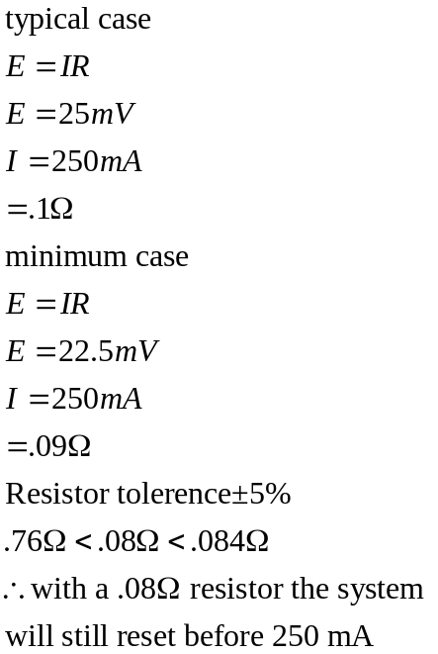

MOSFET Selection
The MAX5904 Drives a N- Channel MOSFET to control the flow of current in the circuit, if the MAX5904 is below the 250 mA (and everything else is connected correctly) limit it will send a high signal to the MOSFET saturating it allowing current to flow if the current exceeds the 250mA limit the MX5904 will not enable the MOSFET. This MOSFET must be selected with some care both to ensure it will switch at the levels provide by the MAX5904 and so it will not utilize much current itself.

The MAX 5904 supplies a high signal between 3.6V and 5.8V and since MOSFETS are charge controlled devices, one only has to ensure the Gate threshold voltage is met and there is ample current supplied to ensure a fast enough switch. For our satellite near instantaneous is ideal. For our chosen N- Channel MOSFET (irlml2502 ) the switching calculation is as follows
Equation 2
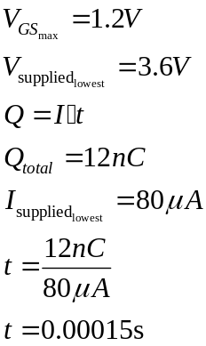
Also important in MOSFET selection is the devices Current consumption as MOSFETS have a resistance associated with them when enabled
.
Equation 3
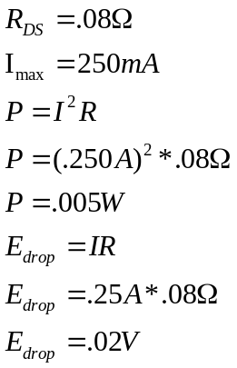

Voltage regulation
The max8887 is a low Drop out linear regulator which means that it will be able to reliably deliver a constant voltage (3.3V) up to a cut of point .2 mV (3.7V) above its designed output. This device also is equipped with a bypass capacitor that can be used to limit the devices noise on the ground plane causing less distortion for the radio.

For this device to work properly the data sheet suggest that filtering capacitors be placed on both the inputs and the outputs it is recommended that these filtering capacitors be 2.2uF with an ESR (equivalent series resistance) of .1 attaching a resistor between the bypass pin an ground creates a low pass filter eliminating some of the higher harmonics from the max8887.

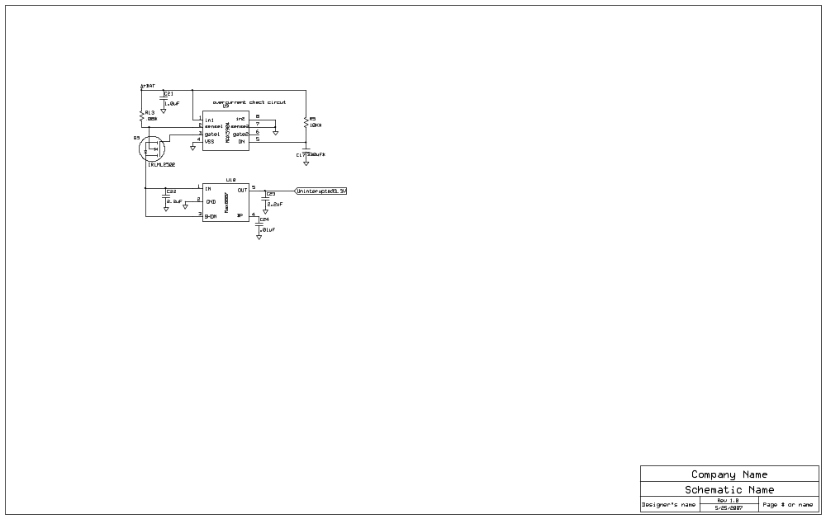
Figure 1: 3.3V uninterruptible supply circuit

5 volt line
The 5V line will only power the onboard handheld radio and will not require protection circuit (it is better to power a failing radio and be short power for other systems then it is to limit power to the radio and not be able to receive or transmit) 5 Volts is generated from the battery voltage (3.7-4.2V) using a Max1790 dc-dc converter this device is capable of supplying 5V .8A in the configuration shown in Figure 2.

There are several required components for this device to operate correctly these include the 3.3μH inductor, a 4.7Ω resistor, two bypass capacitors (.22μF & .68μF) The data sheet for the MAX1790 goes into detail regarding these components. The Filtering capacitors are specified by the data sheet to be 100μF and 33μF although the 33μF capacitor could be replaced with a higher value to improve efficiency with Lithium ion batteries however this needs to be experimented with. The diode chosen is a standard Schottky diode that has been used elsewhere in the circuit. The MAX1790 also has the option to force PWM operation, although there is a trade off regarding efficiency when there is little to no draw on current, this mode forces any noise to be generated at or around 1 MHZ so filtering it out is easily accomplished.
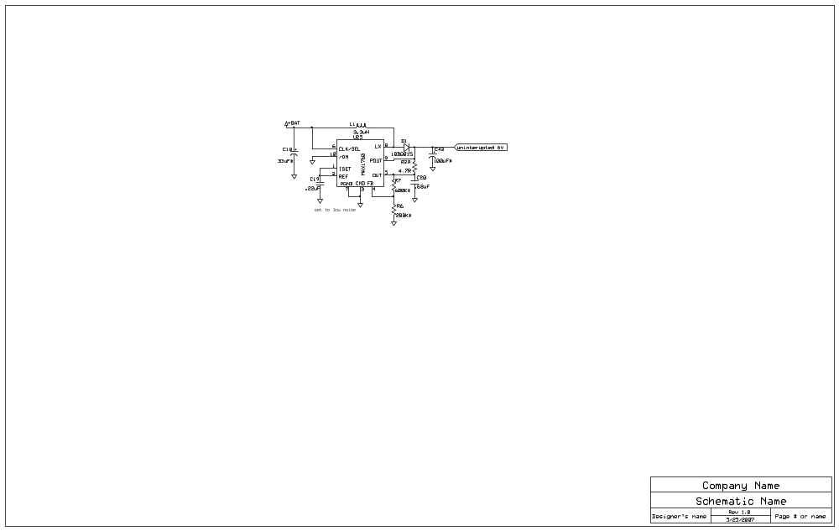
Figure 2: 5 volt step up and supply circuit

Controllable Feed lines
The controllable feed lines are very similar to the 3.3V uninterrupted line only the automatic retry breaker is replaced with a latched breaker that requires a reset in the event of it tripping, however the MAX5905 is practically identical to the MAX5904 so similar analysis can be used to size current sensing resistors the only other difference is some controllable lines use larger Voltage regulators to handle extra current for the heating and ACS subsystems.

3.3V 250 mA lines

Sizing the sense resistor for 250 mA
Equation 4
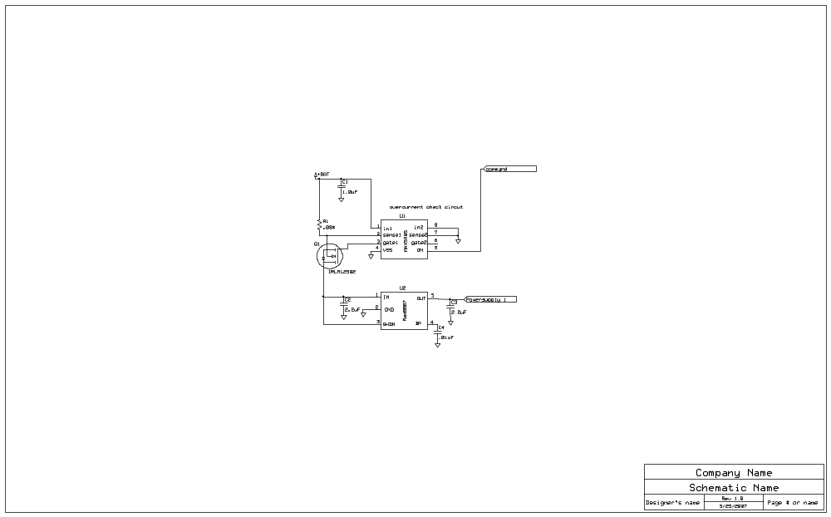
Figure 3: 3.3V 250 mA power supply lines (PS 1&3)

3.3V 850 mA lines

Sizing the sense resistor for 850mA
Equation 5
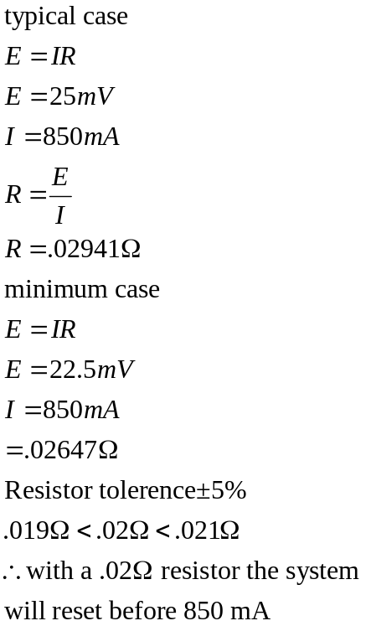

TPS79601
The TPS79601 was selected to replace the MAX8887 as it is capable of sourcing the current required whereas the MAX8887 is only capable on paper of sourcing 300mA this device is again a linear LDO regulator. The main difference is the package design and the ability to source more current filtering & bypass capacitors are sized the same as the MAX8887 to simply the ordering process.
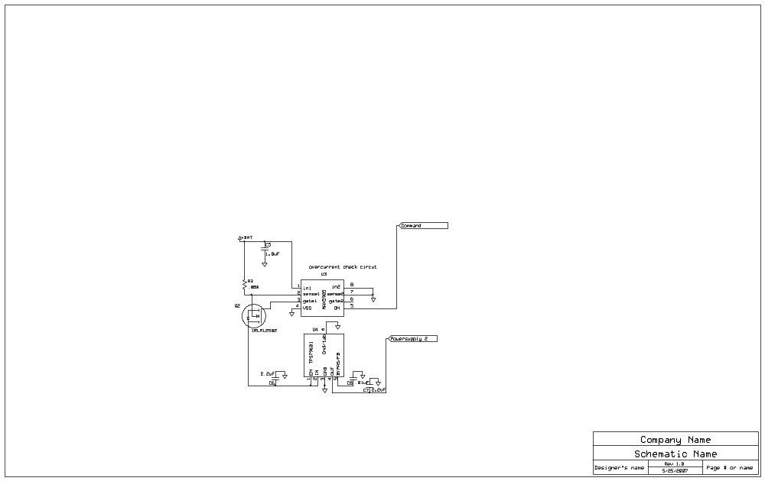
Figure 4: 3.3V 800 mA power supply line (PS 2 & 4)

Feed line control mechanism
The feed line control mechanism acts as a hardware AND gate checking to see if the battery is past the battery’s low voltage threshold and if the microcontroller is commanding for the system to be on.

Minimum voltage detection
Most lithium ion Cells are capable of discharging well below their safe recharge voltage (typically 3V) so a protection circuit must be in place to ensure the battery does not over discharge. This problem is a bit of a paradox for the C&DH/COMM subsystem which must always be on and functioning after deployment (to debug the satellite, to receive commands, etc.). to compromise the minimum cut off voltage has been raised from 3V to 3.3V and the cut off circuit will only power off non critical subsystems, this should prevent the battery from being over discharged and allow the C&DH/COMM subsystem remain powered despite the rest of the satellite being turned off

LTC1440 &SN74LVC1G14 configuration
The LTC1440 is a comparator in this configuration it is set to send a signal when a the device passes a certain voltage in this case 3.3V the LTC1440 will send its signal when it is past this trigger voltage so an inverter is used (SN74LVC1G14) to invert and stabilize the signal, the inverter also is capable of sinking the current from the pull-up resistor used to ensure the octal buffer stays on until the trip point.

To allow the battery pack to recharge properly a hysteresis is required around the trip point to allow the battery time to actually maintain the charge.

The Datasheet for the LTC1440 indicates a design process for selecting resistor values to the final decision on resistors can be made using that procedure and should be verified with the spreadsheet tool embedded in this document

Equation 6: math used to verify LTC resistors
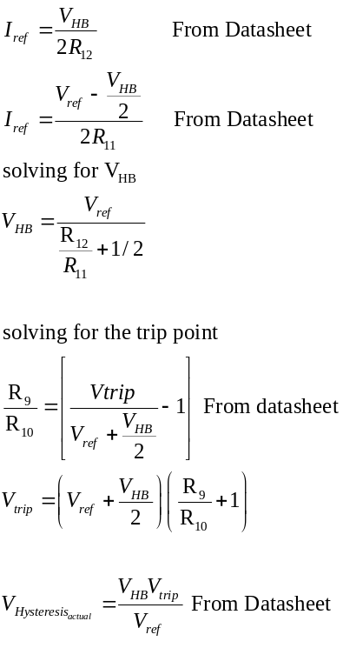

Table 5: Verification tool (embedded spreadsheet if file in .doc format)
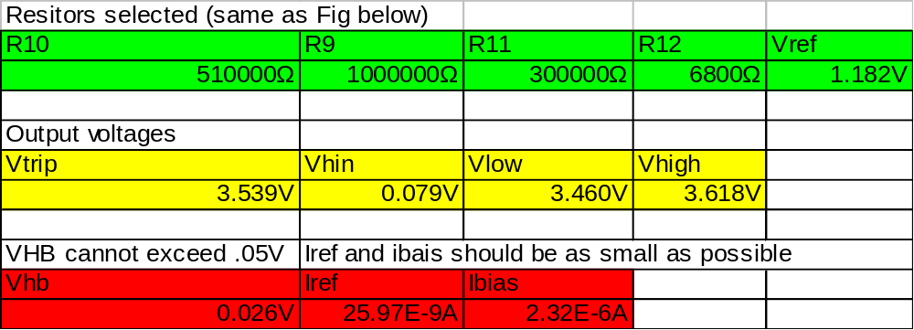
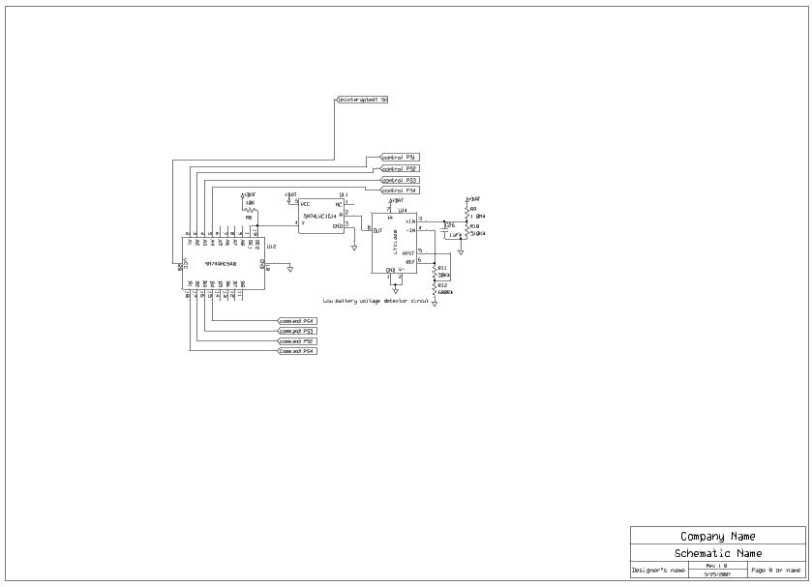
Figure 5: feed line control mechanism

OCTAL BUFFER
The octal buffer chosen (SN74AHC540) acts as an and gate checking to see if there is sufficient power and if there is a command from the microcontroller to enable the subsystem the octal buffer combines all the individual and functions into a single device and allows for future modification

Solar cell measurement and power transfer bus
This part of the circuit has been designed to function with a wide variety of solar cells and is adaptable to different configurations for future missions. The input bus consists of 5 double configuration cells, one single cell configuration and one crossover link,

Standard double cell case
The double cell case was designed to measure the current of one side utilizing a LT1787 current sensor. A 10bq015 Schottky diode is used to protect the solar cell and current sensor from reverse currents.

Sizing the current sensor
The solar cell manufacturer indicates the peak power of the cells occurs at 2.4 V per cell and 400mAhrs for the given size selected. The current sensor can be sized by simply using ohms law

Equation 7
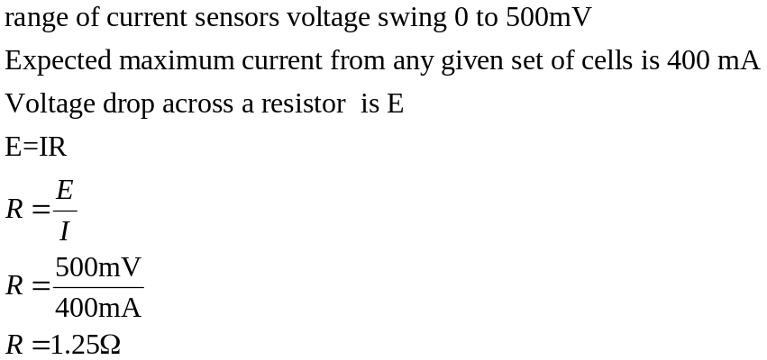

Diode selection
The schottky (10bq015) diode selected was chosen to minimize voltage drop across the diode to maximize the power supplied to the charging bus. It was also chosen to prevent a maximum current of 800 mA from traveling in reversing through the solar cells not producing power

Table 6: Key Diode Characteristics
Max average forward current | 1A
Max peak forward current | 140 A
Max Forward voltage drop | .34V
Max reverse leakage current 25ºC | .50 mA
Max Reverse leakage current 100 ^{c}o | 12 mA
Max Reverse DC voltage | 15V (25V Peak)

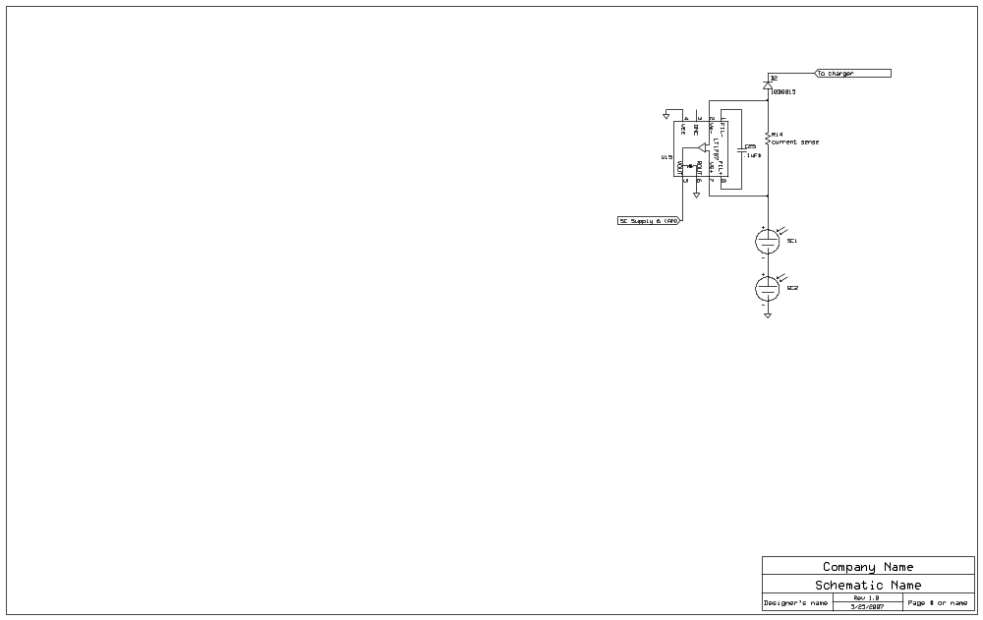

Figure 6: two solar cell circuit

One cell case
The one cell is left open for flight testing a solar cell from any manufacturer; it may or may not be used in the final design however provisions have been made for its future use
Some considerations to keep in mind the lt1787 will not function to specification if the input voltage is below 2.5V this one cell case can also be used to verify on a small scale the operation of the charging circuit

Sizing the current sensor
Sizing the current resistor is exactly the same as the 2 cell case (as the current produced should be the same close to the same or similar)

Equation 8

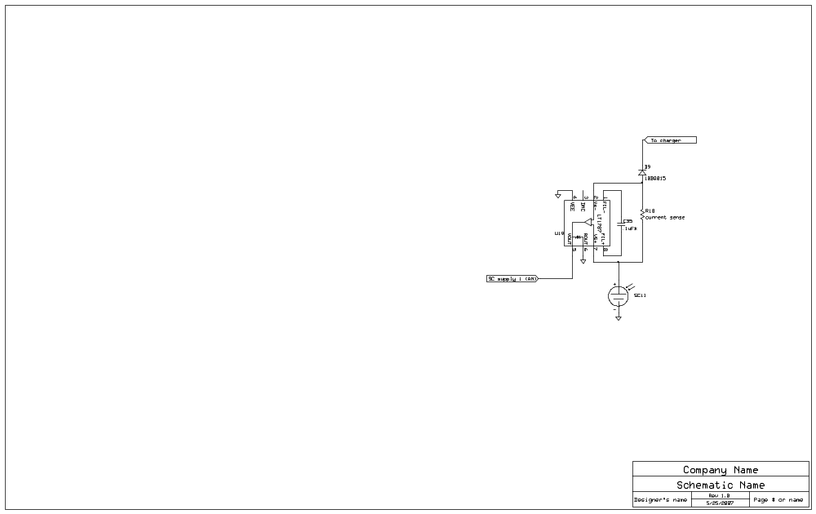
Figure 7: single solar cell circuit

Battery charger
The main component of the battery charging system is the bq24002 from Texas instruments. This device along with a DC- DC voltage converter (MAX1760), a voltage divider and a breakout point will charge the battery and supply current for the system when it is in the light

BQ24002 monolithic charger IC
This device was selected among the many available on the market for its simplicity, ability to change charge current, indication of charge status features, and easy to solder TSSOP package. This device however has a slightly higher input voltage (4.6V where the solar cells in theory can produce a maximum of 4.8V at peak power). This requires the use of a DC-DC converter, to ensure power will transfer from the cells on non ideal orientations. To ensure this device utilizes the most amount of available solar power and does not burn out the DC-DC voltage step up converter the charge current will be limited to .7A (<.1A less then the maximum indicated in the datasheet)

Equation 9: sense resistor sizing verification
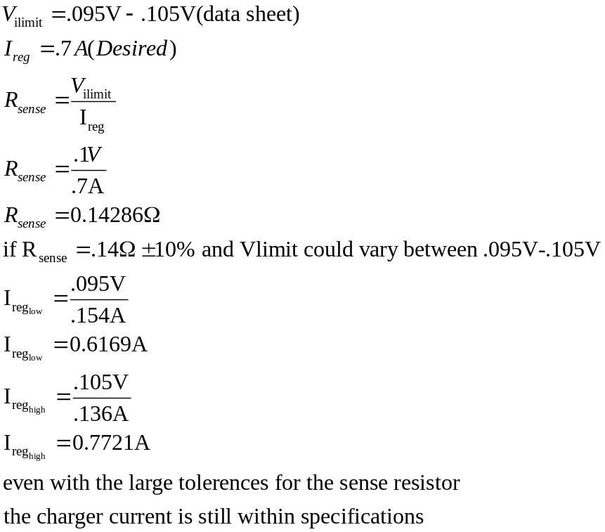

Max 1760 voltage boosting circuit
This circuit is exactly the same as the boosting circuit used to boast the voltage on the 5 volt line
There are several required components for this device to operate correctly these include the 3.3μH inductor, a 4.7Ω resistor, two bypass capacitors (.22μF & .68μF) The data sheet for the MAX1790 goes into detail regarding these components. The Filtering capacitors are specified by the data sheet to be 100μF and 33μF although the 33μF capacitor could be replaced with a higher value to improve efficiency with Lithium ion batteries however this needs to be experimented with. The diode chosen is a standard Schottky diode that has been used elsewhere in the circuit. The MAX1790 also has the option to force PWM operation, although there is a trade off regarding efficiency when there is little to no draw on current, this mode forces any noise to be generated at or around 1 MHZ so filtering it out is easily accomplished.

Solar cell output
Because multiple cells are connected to the same buss and a peak power point management circuit is not used, some analysis must be completed to ensure there is not too much power on the charging bus that may cause damage the charger.
The first assumption is the peak power from any given set of cells could be .4A at 4.8V if

NEED REVIEW OF ADMITANCE HERE

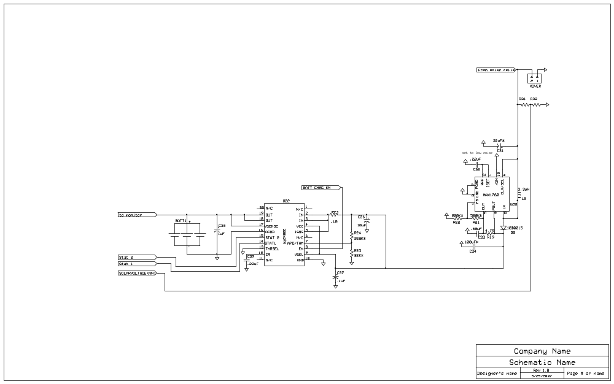
Figure 8: Battery charger circuit

Battery monitor
the battery monitor will consist of the subsystem microcontroller estimating the battery draw/recharge current over time, to do this a current sensor(LT1787) will be used to directly measure the current, also to help verify these estimates, the battery voltage will be measured using a simple voltage divider

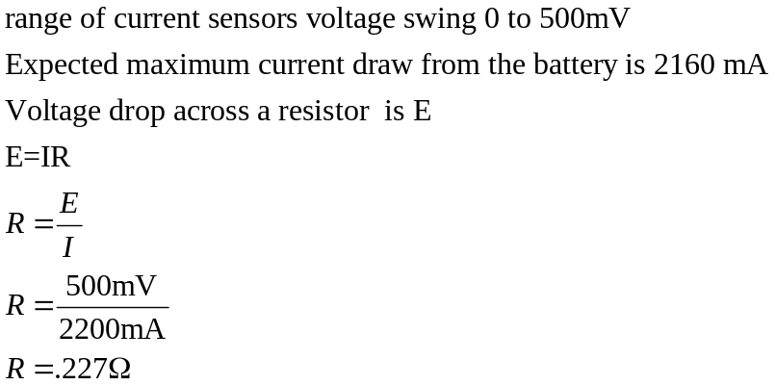
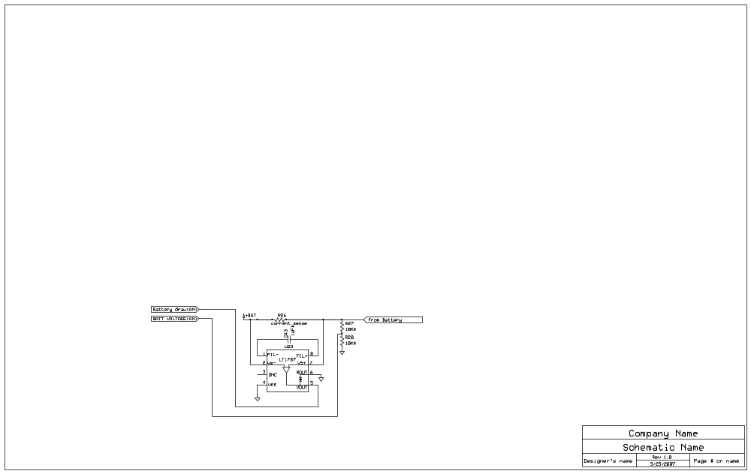
Figure 9: battery monitor circuit

System wide interface
The power subsystem will be connected to the rest of the satellite using a standardized interface this interface includes a 30 pin connector a bus switch, and programming enable jumpers
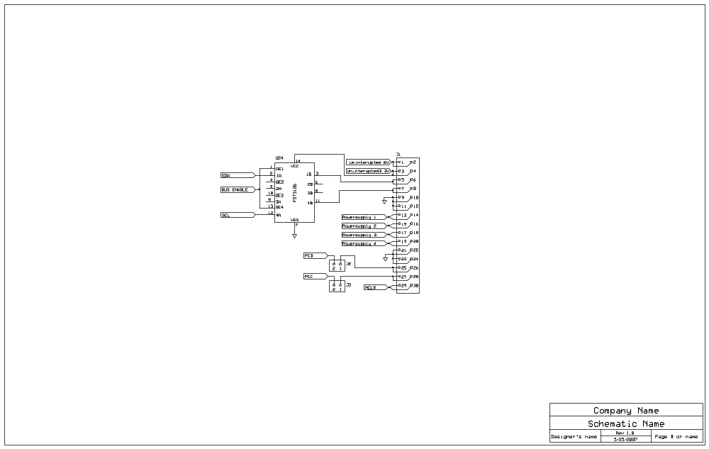
Figure 10: interface to the rest of the satellite

Microcontroller
the following drawing indicates the connections made to the microcontroller (PIC 16F777) as it can be seen from Figure 11the microcontroller acts only to gather the sensor data (mainly Analog data) and control the power supply enable pins.
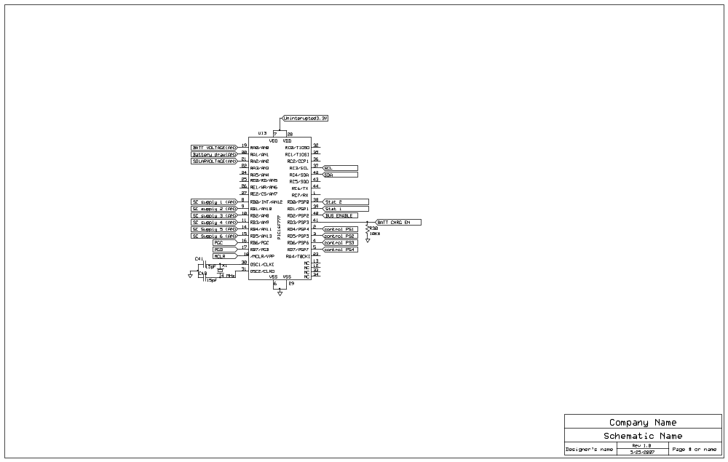
Figure 11: microcontroller pin-out

Overall schematic design
The following figures show the full circuit in detail.
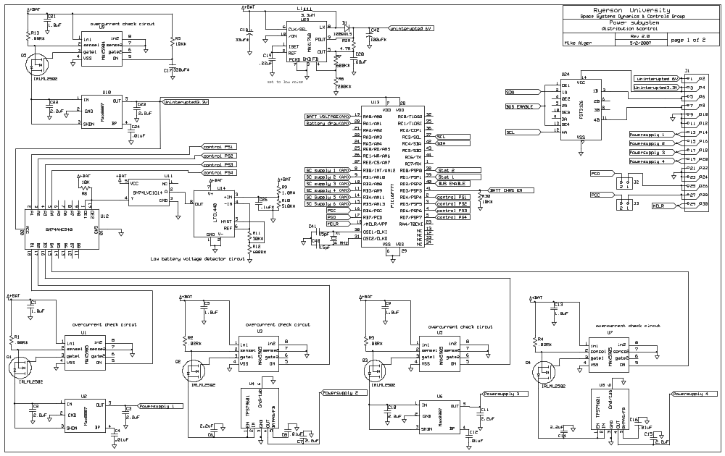
Figure 12:
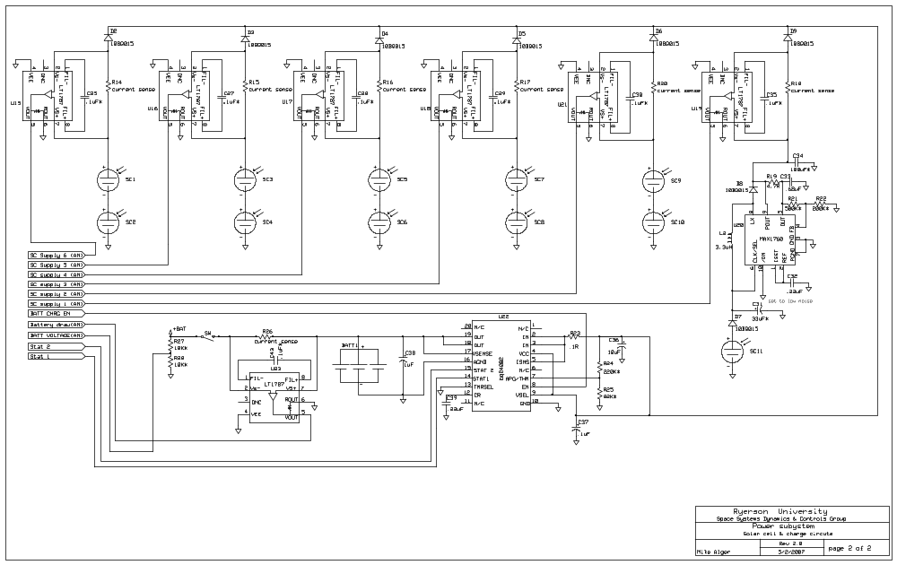
Figure 13:

Physical implementation
the power subsystem circuit must only occupy one single PCB card in the satellite a battery will rest on a second blank PCB and will be connected to the first using a right angle Molex connector.

PCB Design
The following figure illustrates the layout of the final power subsystem.
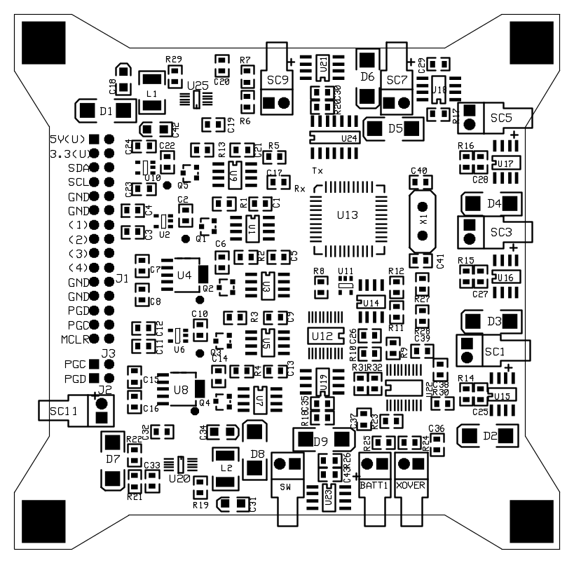
Figure 14: PCB layout

Hand Assembly instructions
Hand assembly will be done in the following manner to ensure repeatability and reliability. The overall process will take the philosophy of placing the shortest components first and building simple testable blocks

Battery terminal connection
Step | instructions | √
0 | Solder sw
1 | Solder R24
2 | Solder R25
3 | Solder R23
4 | Solder R26
5 | Solder C43
6 | Solder C36
7 | Solder C37
8 | Solder U23
9 | Solder BATT1 terminal

Test work
- Attach a voltage source (~4.5V)to BATT1 (negative lead should be the square pad or right side of the connector if viewed from the top in Figure 14)
- Verify that the voltage between the ground plane and the power plane (corners are connected to ground and a test point for the power plane is around R13) is the nearly the same as the voltage source (there are extremely small losses from the
- Disconnect the voltage source

Uninterruptible 3V

Step | instructions | √
1 | Solder U10
2 | Solder C24
3 | Solder C23
4 | Solder C22
5 | Solder Q5
6 | Solder R13
7 | Solder C21
8 | Solder R5
9 | Solder C17
10 | Solder U9

Test work
- Attach a voltage source (~4.5V) to BATT1 (negative lead should be the square pad or right side of the connector if viewed from the top in Figure 14)
- Verify that the voltage between the ground plane and the power plane (corners are connected to ground and a test point for the power plane is around R13) is the nearly the same as the voltage source (there are extremely small losses from the current sense resistor)
- Test the 3.3V(U) source at the system interface (J1) it should be 3.3V
- Disconnect the voltage source

Uninterruptible 5V
Step | Instructions | √
1 | Solder U25
2 | Solder C19
3 | Solder C42
4 | Solder R6
5 | Solder R7
6 | Solder C20
7 | Solder R29
8 | Solder C18
9 | Solder L1
10 | Solder D1

Test work
- Attach a voltage source (~4.5V) to BATT1 (negative lead should be the square pad or right side of the connector if viewed from the top in Figure 14)
- Verify that the voltage between the ground plane and the power plane (corners are connected to ground and a test point for the power plane is around R13) is the nearly the same as the voltage source (there are extremely small losses from the current sense resistor)
- Test the 5V(U) source at the system interface (J1) it should be 5V
- Disconnect the voltage source

Controllable supply 1 (PS1)
Step | Instructions | √
1 | Solder U2
2 | Solder Q1
3 | Solder C4
4 | Solder C3
5 | Solder C2
6 | Solder R1
7 | Solder C1
8 | Solder U1

Test work
- Attach a voltage source (~4.5V) to BATT1 (negative lead should be the square pad or right side of the connector if viewed from the top in Figure 14)
- Verify that the voltage between the ground plane and the power plane (corners are connected to ground and a test point for the power plane is around R13) is the nearly the same as the voltage source (there are extremely small losses from the current sense resistor)
- Test the pads labelled (1) at J1 it should be 0V
- Short pin 5 on U1 to the 3.3V(U) source using a 10 k resistor
- Test the pads labelled (1) at J1 it should be 3.3V
- Disconnect the voltage source

Controllable supply 2 (PS2)
Step | Instructions | √
1 | Solder Q2
2 | Solder C8
3 | Solder C7
4 | Solder C6
5 | Solder R2
6 | Solder C5
7 | Solder U4
8 | Solder U3

Test work
- Attach a voltage source (~4.5V) to BATT1 (negative lead should be the square pad or right side of the connector if viewed from the top in Figure 14)
- Verify that the voltage between the ground plane and the power plane (corners are connected to ground and a test point for the power plane is around R13) is the nearly the same as the voltage source (there are extremely small losses from the current sense resistor)
- Test the pads labelled (2) at J1 they should be 0V
- Short pin 5 on U3 to the 3.3V(U) source using a 10 k resistor
- Test the pads labelled (2) at J1 they should be 3.3V
- Disconnect the voltage source

Controllable supply 3 (PS3)
Step | Instructions | √
1 | Solder U6
2 | Solder Q3
3 | Solder C12
4 | Solder C11
5 | Solder C10
6 | Solder R3
7 | Solder C9
8 | Solder U5
9
10

Test work
- Attach a voltage source (~4.5V) to BATT1 (negative lead should be the square pad or right side of the connector if viewed from the top in Figure 14)
- Verify that the voltage between the ground plane and the power plane (corners are connected to ground and a test point for the power plane is around R13) is the nearly the same as the voltage source (there are extremely small losses from the current sense resistor)
- Test the pads labelled (3) at J1 they should be 0V
- Short pin 5 on U1 to the 3.3V(U) source using a 10 k resistor
- Test the pads labelled (3) at J1 they should be 3.3V
- Disconnect the voltage source

Controllable supply 4 (PS3)
Step | Instructions | √
1 | Solder U8
2 | Solder Q4
3 | Solder C16
4 | Solder C15
5 | Solder C14
6 | Solder R4
7 | Solder C13
8 | Solder U7
9
10

Test work
- Attach a voltage source (~4.5V) to BATT1 (negative lead should be the square pad or right side of the connector if viewed from the top in Figure 14)
- Verify that the voltage between the ground plane and the power plane (corners are connected to ground and a test point for the power plane is around R13) is the nearly the same as the voltage source (there are extremely small losses from the current sense resistor)
- Test the pads labelled (4) at J1 they should be 0V
- Short pin 5 on U1 to the 3.3V(U) source using a 10 k resistor
- Test the pads labelled (4) at J1 they should be 3.3V
- Disconnect the voltage source

Jumpers
Step | Instructions | √
1 | Solder J1
2 | Solder J2&J3

Test work
- With an closed jumper 2 Check continuity between the PGD on J1 to pin 17 on U13
- With an closed jumper 2 Check continuity between the PGC on J1 to pin 16 on U13
- Check continuity of joints on J1

Single solar cell
Step | Instructions | √
1 | Solder U20
2 | Solder C33
3 | Solder R21
4 | Solder R19
5 | Solder C32
6 | Solder L2
7 | Solder C31
8 | Solder C34
9 | Solder D7
10 | Solder D8
 | Solder SC11

Test work
- Attach a voltage source (~2.4V) to SC11
- Check voltage between ground and R18 (should be around 4.2 V)
- Disconnect voltage source
11 | Solder R18
12 | Solder C35
13 | Solder u19

Test work
- Attach a voltage source (~2.4V) to SC11
- Check voltage between ground and R18 (should be around 4.2 V)
- Check output on pin 5 of u19 should be in **** V range
- Disconnect voltage source

Battery charger
Step | Instructions | √
1 | Solder U22
2 | Solder C38
3 | Solder C39
4 | Solder R30
5 | Solder C32
6 | Solder L2
7 | Solder C31
8 | Solder C34
9 | Solder D7
10 | Solder D8
 | Solder SC11

Test work
- Attach a voltage source (~2.4V) to SC11
- Check voltage between ground and R18 (should be around 4.2 V)

Battery level check and main microcontroller
Step | Instructions | √
1 | Solder U13
2 | Solder U11
3 | Solder R8
4 | Solder R12
5 | Solder R11
6 | Solder R27
7 | Solder R28
8 | Solder U14
9 | Solder C26
10 | Solder R10
11 | Solder R9
12 | Solder C40
13 | Solder C41

Test work
- Attach a load to one of the switch able supply lines (led with a current limiting resistor)
- Attach a voltage source (~4.5V) to BATT1
- Dial the voltage down to 3.4V light should extinguish around 3.5
- Dial the voltage up to 4 V light should illuminate around 3.7 V
- Dial voltage back to 4 volts
- Attach board to programming interface attempt communication with PIC
- Disconnect the voltage source

Remaining solar cells
Step | Instructions | √
1 | Solder R20
2 | Solder C30
3 | Solder R17
4 | Solder C29
5 | Solder R16
6 | Solder C28
7 | Solder R28
8 | Solder R15
9 | Solder C27
10 | Solder R14
11 | Solder C25
12 | Solder C40
13 | Solder C41
14 | Solder u21
15 | Solder u24
16 | Solder u18
17 | Solder u17
18 | Solder u16
19 | Solder u15
20 | Solder D6
21 | Solder D5
22 | Solder D4
23 | Solder D3
24 | Solder D2
25 | Solder SC9
26 | Solder SC7
27 | Solder SC5
28 | Solder SC3
29 | Solder SC1
30 | Solder X1

Test work

Modifications/Recommendations/Errors Ver2.1
Design Errors
- Previously undocumented pull down resistors need to be added to this design to deal with tri stated start-up condition of octal buffer
  - Physical workaround planed will attempt to control directly in software in this revision
  - Will correct in next revision

PCB errors
- MOSFETs (Q1-Q5 and thermal) incorrect in June 21st fst fix pcb design and schematic Source and Drain need to be reversed
  - Temporary physical workaround is to bend back pins on MOSFET mount it upside down and a 120 degrees off center
  - Will be corrected in next revision
- U10 has traces to close together (pin 1 and 2)
  - Temporary workaround trace can be cut using scalpel
  - Will correct in next revision (problem traced to movement of part in sent out order )
- C33 not labelled on PCB
  - Found with help from PCB file
  - Will correct in next revision

Assembly Errors
- Anode confused with cathode some devices mounted backward
  - Parts removed and remounted
  - Instructions will be updated to include proper orientation

Ordering errors
- R9 incorrectly ordered as 10Mohm instead of 1Mohm
  - Wire wound resistor used as substitute until surface mount part delivered
- U6 & U8 ordered incorrectly (TPS79601 was ordered instead of TPS79633)
  - Will work with current devices until proper ones are delivered only difference is they will not regulate to 3.3 V (they will regulate to 5.5V

Failure modes
This system may be prone to the following modes of failure

Problem | Failure state/recovery
Battery electrolyte evaporates | Satellite will cease to function
Battery voltage drops to an extremely low voltage | Several recharge cycles are needed to coax the battery charger to normally charge the battery
Power Microcontroller fails | Uninterruptible power sources still available (minimal data collection possible)
Power source 1-4 fails | That subsystem will become unavailable for use (limited mission)
5V U fails | Radio communication impossible (mission failure)
3.3VUfails | C&DH / power subsystem will cease to operated (mission failure)
Low voltage comparator fails | System may sporadically shut off (3.3VU and 5VU are unaffected)
Solar cell array fails | Unable to capture from damaged side others are separate systems and will be fine
Battery charger fails | Satellite will cease to function (no other bypass is available on the board)

Software design
The power subsystem has the following tasks to accomplish in software
- report battery life estimates
- report battery voltage
- report solar cell outputs
- keep track of battery statistics
- keep track of # of power related faults (tripped breakers etc)
- control power to other subsystems

Pseudo code design
The following diagram is presented to explain the operation of the code

C Code

Testing instructions
- Bill of materials

part name | Value or name | Digi-key part number | Cost | weight | mark on part
BATT1
C1 | 1.0uF
C2 | 2.2uF | PCC2320CT-ND
C3 | 2.2uF | PCC2320CT-ND
C4 | .01uF
C5 | 1.0uF
C6 | 2.2uF | PCC2320CT-ND
C7 | 2.2uF | PCC2320CT-ND
C8 | .01uF
C9 | 1.0uF
C10 | 2.2uF | PCC2320CT-ND
C11 | 2.2uF | PCC2320CT-ND
C12 | .01uF
C13 | 1.0uF
C14 | 2.2uF | PCC2320CT-ND
C15 | 2.2uF | PCC2320CT-ND
C16 | .01uF
C17 | 330uF*
C18 | 33uF* | 478-1755-1-ND
C19 | .22uF | 445-2512-1-ND
C20 | .68uF | 478-1404-1-ND
C21 | 1.0uF
C22 | 2.2uF | PCC2320CT-ND
C23 | 2.2uF | PCC2320CT-ND
C24 | .01uF
C25 | .1uF*
C26 | .1uF*
C27 | .1uF*
C28 | .1uF*
C29 | .1uF*
C30 | .1uF*
C31 | 33uF*
C32 | .22uF
C33 | .68uF
C34 | 100uF*
C35 | .1uF*
C36 | 10uF
C37 | .1uF
C38 | 1uF
C39 | .22uF
C40 | 15pF
C41 | 15pF
C42 | 100uF* | 478-3260-1-ND
C43 | .1uF*
D1 | 10BQ015 | 10BQ015PBFCT-ND
D2 | 10BQ015 | 10BQ015PBFCT-ND
D3 | 10BQ015 | 10BQ015PBFCT-ND
D4 | 10BQ015 | 10BQ015PBFCT-ND
D5 | 10BQ015 | 10BQ015PBFCT-ND
D6 | 10BQ015 | 10BQ015PBFCT-ND
D7 | 10BQ015 | 10BQ015PBFCT-ND
D8 | 10BQ015 | 10BQ015PBFCT-ND
J1 | 30 pin rt angle | Hrs30h-nd
J2
J3
L1 | 3.3uH
L2 | 3.3uH
Q1 | IRLML2502 | IRLML2502PBFCT-ND
Q2 | IRLML2502 | IRLML2502PBFCT-ND
Q3 | IRLML2502 | IRLML2502PBFCT-ND
Q4 | IRLML2502 | IRLML2502PBFCT-ND
Q5 | IRLML2502 | IRLML2502PBFCT-ND
R1 | .08* | WSLA-.08CT-ND
R2 | .08* | WSLA-.08CT-ND
R3 | .08* | WSLA-.08CT-ND
R4 | .08* | WSLA-.08CT-ND
R5 | 10K*
R6 | 200K*
R7 | 600K*
R8 | 10K
R9 | 1.0M*
R10 | 510K*
R11 | 30K*
R12 | 680R*
R13 | .08* | WSLA-.08CT-ND
R14 | current sense
R15 | current sense
R16 | current sense
R17 | current sense
R18 | current sense
R19 | 4.7R
R20 | current sense
R21 | 500K*
R22 | 200K*
R23 | .1R
R24 | 220K*
R25 | 82K*
R26 | current sense
R27 | 10K*
R28 | 10K*
R29 | 4.7R
R30 | 10K*
SC1
SC2
SC3
SC4
SC5
SC6
SC7
SC8
SC9
SC10
SC11
U1 | MAX5905 | MAX5905SA
U2 | Max8887 | MAX8887EZK33+ T
U3 | MAX5905 | MAX5905SA
U4 | TPS79601 | 296-13761-1-ND
U5 | MAX5905 | MAX5905SA
U6 | Max8887 | MAX8887EZK33+ T
U7 | MAX5905 | MAX5905SA
U8 | Max8887 | MAX8887EZK33+ T
U9 | MAX5904 | MAX5904SA
U10 | Max8887 | MAX8887EZK33+ T
U11 | SN74LVC1G14 | 296-11607-1-ND
U12 | SN74AHC540 | 296-4607-1-ND
U13 | PIC16F777 | PIC16F777-I/PT-ND
U14 | LTC1440 | LTC1440CS8-ND
U15 | LT1787 | LT1787HVCS8#PBF-ND
U16 | LT1787 | LT1787HVCS8#PBF-ND
U17 | LT1787 | LT1787HVCS8#PBF-ND
U18 | LT1787 | LT1787HVCS8#PBF-ND
U19 | LT1787 | LT1787HVCS8#PBF-ND
U20 | MAX1760 | MAX1760EUB-ND
U21 | LT1787 | LT1787HVCS8#PBF-ND
U22 | bq24002
U23 | LT1787 | LT1787HVCS8#PBF-ND
U24 | FST3126
U25 | MAX1760 | MAX1760EUB-ND
X1 | 4 MHz | CTX402-ND

  - Final satellite
    - Components
      - C&DH board

(note this may be changed in a future revision to utilize a simpler system)

